ARJAN SINGH NARULA

N15292730

asn419@nyu.edu

CV Project 1

1.Source Code: ARJAN_Canny_Edge_Detector.txt

Python File-ARJAN_Canny_Edge_Detector.py

2.Instructions

**Source Code:** To Compile and Run the program follow these steps.

* Copy the source code in python compiling platform like Anaconda(Jupyter)or Pycharm.
* Make sure system has Python Interpreter installed**.**
* Before compiling, make sure that the libraries ‘numpy’, ‘Imageio’, ’PIL’ and ‘matplotlib’ are linked to the project
* After running the code, it will ask you to input the name of image with extension. Image should be on the same folder as the code.
* The code will run and save the output images in the same folder ARJAN_Edge_Detector with name of images.

**3.Output Image Results**

1. **Lena256**

* **Normal Image**

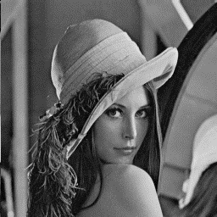

* **Gaussian Smoothed Image**

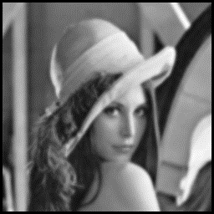

**Fig(1a): Gaussian Smoothed Image**

* **Gradient X**

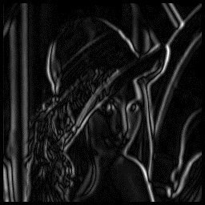

**Fig(2a):Gradient X Image**

* **Gradient Y**

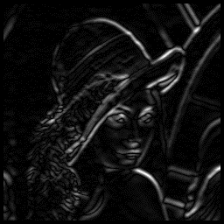

**Fig(3a): Gradient Y Image**

* **Magnitude Image**

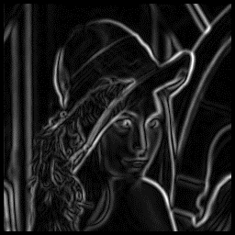

**Fig(4a):Magnitude Image**

* **Non Maxima Suppression**

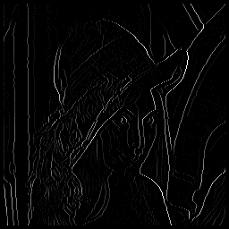

**Fig(5a):Non Maxima Suppression**

* **Ptile=10 Percent**

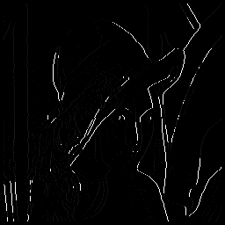

**Fig(6a1):Image for 10 Percent**

**Edges Detected:** 985

**Threshold:** 30

* **Ptile=30 Percent**

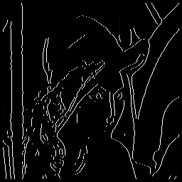

**Fig(6a2): Image for 30 Percent**

**Edges Detected**: 2657

**Threshold**: 15

* Ptile=50 Percent

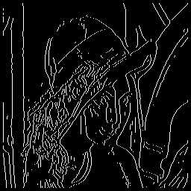

**Fig(6a3): Ptile for 50 Percent**

**Edges Detected**: 4612

**Threshold**: 6

1. **zebra-crossing-1**

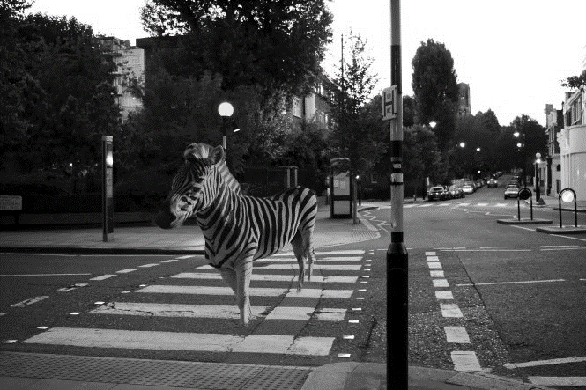

* **Gaussian Smooth Image**

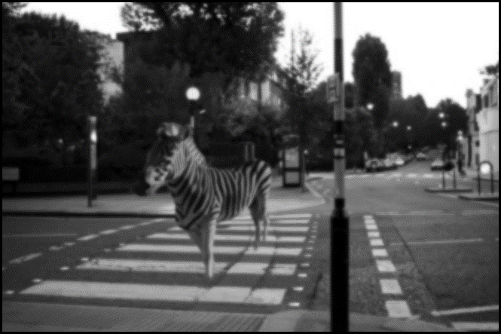

**Fig(1b):Gaussian Smooth Image**

* **Gradient X**

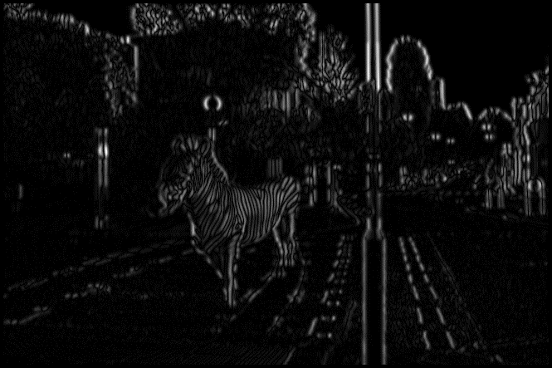

**Fig(2b):Gradient X**

* **Gradient Y**

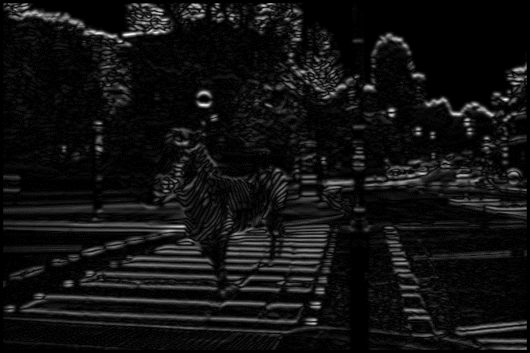

**Fig(3b):Gradient Y**

* **Magnitude Image**

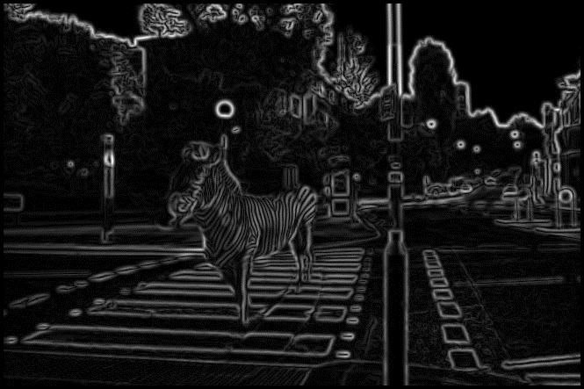

**Fig(4b):Magnitude Image**

* **Non Maxima Suppression**

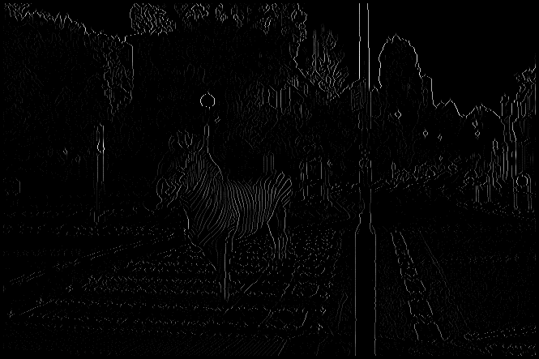

**Fig(5b):Non Maxima Suppression**

* **Ptile=10Percent**

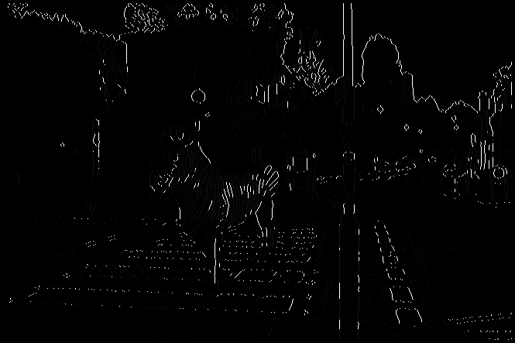

**Fig(6b1): Ptile for 10 Percent**

**Edges Detected**: 3789

**Threshold**: 29

* **Ptile=30 Percent**

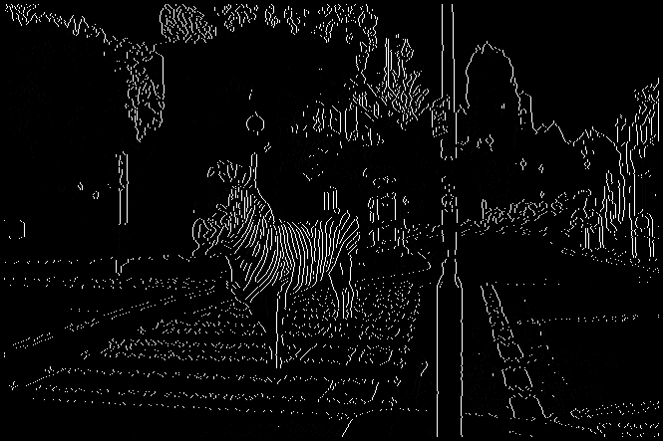

**Fig(6b2): Ptile for 30 Percent**

**Edges Detected**: 11368

**Threshold**: 12

* **Ptile=50 Percent**

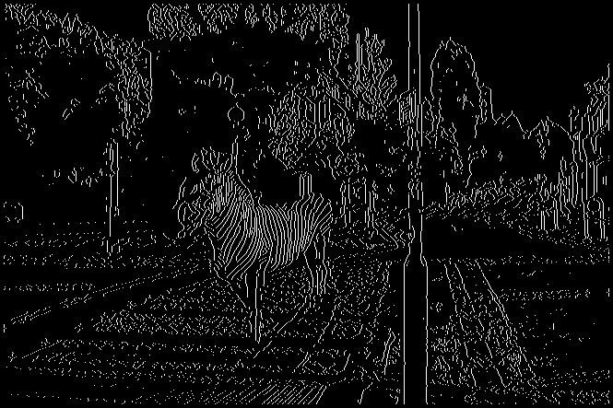

**Fig(6b3): Ptile for 50 Percent**

**Edges Detected:** 18819

**Threshold**: 5

//**Source Code**

from PIL import Image

import numpy as np

from math import sqrt

from math import degrees

import imageio as io

def main():

# Opening image

Imagename=input("Give name of image with extension : ")

img=np.array(Image.open(Imagename))

# Rows and Coloumn of image

x,y=img.shape

# Gaussian convolution mask array

gaussian=np.array([[1,1,2,2,2,1,1],[1,2,2,4,2,2,1],[2,2,4,8,4,2,2],[2,4,8,16,8,4,2],[2,2,4,8,4,2,2],[1,2,2,4,2,2,1],[1,1,2,2,2,1,1]])

# After gaussian smoothed array till now its value are zero as we have not call our gaussian smooth function

gaussiansmootharray= np.zeros((x,y),dtype=np.float)

# Row and coloumn of gaussian mask

rowgaussian,colgaussian=gaussian.shape

# Finding the medium point of gaussian mask for wor and coloumn

rowmedian=rowgaussian//2

colmedian=colgaussian//2

# Called gaussian smoothing function for gaussian smoothing wih image array,gaussian array and gaussian smooth array which is empty

gaussiansmoothing(img,gaussian,gaussiansmootharray,Imagename)

# Array with same size of image but with values 0 for gradient x and gradient y

gx=np.zeros((x,y),dtype=np.float)

gy=np.zeros((x,y),dtype=np.float)

# Array with same size of image for gradient x and gradient y with values 0 but it is used to contains negative value too for angle array.

gx1=np.zeros((x,y),dtype=np.float)

gy1=np.zeros((x,y),dtype=np.float)

# Call gradient operator function for calculating gradient x an gradient y

gradientoperator(gaussiansmootharray,gx,gy,gx1,gy1,Imagename )

# Magnitude array initialize for storing magnitudes of image after gradient operation

magnitduearray=np.zeros((x,y),dtype=np.float)

# Angle array for storing angles after gradient operation

anglearray=np.zeros((x,y),dtype=np.float)

# Call gradient magnitude function for calculating the magnitudes and angle of intensities.

gradientmagnitude(gx1,gy1,magnitduearray,Imagename)

# Initialize array for storing results after non maxima suppression

after_nonmaximasppression=np.zeros((x,y),dtype=np.float)

# Call non maxima suppression function to calulate non maxima.

non_maxima_suppression(magnitduearray,anglearray,after_nonmaximasppression,Imagename)

# Taking the result of non maxima suppression and applying it to ptile function for calulation of ptile, threshold and detecting the number of edges in a image

ptile1=[0.1,0.3,0.5]

for i in range(len(ptile1)):

print("Ptile for",ptile1[i]*100,"percent")

ptile(after_nonmaximasppression,ptile1[i],Imagename)

def multiply(imgarr,gaussianarr,startrow,startcol,gaussianstartrow,gaussianstartcol):

sum=0

i=startrow

j=startcol

e=gaussianstartrow

f=gaussianstartcol

for a in range(e):

j=startcol

for b in range(f):

c=imgarr[i][j]*gaussianarr[a][b]

sum=sum+c

j=j+1

i=i+1

return sum

def gaussiansmoothing(img,gaussian,gaussiansmootharray,Imagename):

# Row and Column of Image

x,y=img.shape

# Row and Column of Gaussian Mask

rowgaussian,colgaussian=gaussian.shape

# Medium for Row and Coloumn of Gaussian Mask

rowmedian=rowgaussian//2

colmedian=colgaussian//2

# Works will i and j are in range of rows and coloumn for image

for i in range(x):

for j in range(y):

# checking whether the above or below pixels or above pixel are in range of Gaussian Mask so that my gaussian filter doesnot go outside the image.

d=i-rowmedian

e=i+rowmedian

if((d)in range(x)):

if((e)in range(x)):

# checking whether the left or right side pixel are in range of Gaussian Mask so that my gaussian filter doesnot go outside the image.

f=j-colmedian

h=j+colmedian

if((f)in range(y)):

if((h)in range(y)):

# if they are not outside range, we will send the image array with gaussian mask and starting range of both array for convolution and store the result at this point.

gaussiansmootharray[i][j]=multiply(img,gaussian,i-rowmedian,j-colmedian,rowgaussian,colgaussian)

# Normalizing the convolution result by dividing by 40.

gaussiansmootharray[i][j]=gaussiansmootharray[i][j]/140

# Display image after Gaussian Smoothing

import imageio as i

i.imwrite("Gaussiam Smoooth_ %s.bmp"%Imagename,gaussiansmootharray)

print("Gaussian Smooth Image")

%matplotlib inline

from matplotlib import pyplot as plt

plt.imshow(gaussiansmootharray,cmap="gray")

plt.show()

def gradientoperator(gaussiansmootharray1,gx,gy,gx1,gy1,Imagename):

gaussian=np.array([[1,1,2,2,2,1,1],[1,2,2,4,2,2,1],[2,2,4,8,4,2,2],[2,4,8,16,8,4,2],[2,2,4,8,4,2,2],[1,2,2,4,2,2,1],[1,1,2,2,2,1,1]])

rowgaussian,colgaussian=gaussian.shape

rowmedian=rowgaussian//2

colmedian=colgaussian//2

# Creating Prewitt Operator Sx and Sy for calculating Gradient X and Gradient Y

perwittoperatorsx=np.array([[-1,0,1],[-1,0,1],[-1,0,1]])

# Size of Sx

perwittoperatorsxx,perwittoperatorsxy=perwittoperatorsx.shape

perwittoperatorsy=np.array([[1,1,1],[0,0,0],[-1,-1,-1]])

# Size of Sy

perwittoperatorsxx1,perwittoperatorsxy1=perwittoperatorsy.shape

x1,y1=gaussiansmootharray1.shape

# Medium of row and coloumn for Prewitt Operator

rowmediangradient=perwittoperatorsx/2

colmediangradient=perwittoperatorsx/2

#Defining the range till when the prewitt operator convolution works.

looprowrange=x1-rowgaussian+rowmedian

loopcolrange=y1-colgaussian+colmedian

# Starting point for storing the result after prewitt operation

a=rowgaussian//2+1

b=colgaussian//2+1

while(a<looprowrange):

b=colgaussian//2+1

while(b<loopcolrange):

# If my values are in range, it will call the multiply funciton for convolution between the prewitt Sx and Gaussian Smooth Array.

gx[a][b]=multiply(gaussiansmootharray1,perwittoperatorsx,a-1,b-1,perwittoperatorsxx,perwittoperatorsxy)

# Storing the result in Gx1 for negative values for angle array.

gx1[a][b]=gx[a][b]

# Using absolute values and normalize the result.

gx[a][b]=abs(gx[a][b])

gx1[a][b]=gx1[a][b]/3

gx[a][b]=gx[a][b]/3

# # If my values are in range, it will call the multiply funciton for convolution between the prewitt Sy and Gaussian Smooth Array.

gy[a][b]=multiply(gaussiansmootharray1,perwittoperatorsy,a-1,b-1,perwittoperatorsxx1,perwittoperatorsxy1)

#Storing the Result in Gy1 for negative value for angle array.

gy1[a][b]=gy[a][b]

# Using absolute values and normalizing the result.

gy[a][b]=abs(gy[a][b])

gy[a][b]=gy[a][b]/3

gy1[a][b]=gy1[a][b]/3

b=b+1

a=a+1

#Output Image after Gradient Operation for Gx and Gy.

print("Gradient X")

import imageio as i

i.imwrite("GradientX_ %s.bmp"%Imagename,gx)

i.imwrite("GradientY_ %s.bmp"%Imagename,gy)

%matplotlib inline

from matplotlib import pyplot as plt

plt.imshow(gx,cmap="gray")

plt.show()

print("Gradient Y")

plt.imshow(gy,cmap="gray")

plt.show()

def gradientmagnitude(gradientx, gradienty,magnitduearray,Imagename):

#Rows and Column for Gradient X.

x,y=gradientx.shape

#Checking that variable are in range of array.

for a in range(x):

for b in range(y):

#Calculating the magnitude by taking Gx,Gy at this point and normalizing the result.

magnitduearray[a][b]=((gradientx[a][b]*gradientx[a][b])+(gradienty[a][b]*gradienty[a][b]))

magnitduearray[a][b]=sqrt(magnitduearray[a][b])

magnitduearray[a][b]=magnitduearray[a][b]/1.4142

c=gradienty[a][b]/gradientx[a][b]

# calculating the angle at each point and converting the result into degrees.

anglearray=np.arctan2(gradienty,gradientx)

x,y=gradientx.shape

for e in range(x):

for l in range(y):

anglearray[e][l]=degrees(anglearray[e][l])

# Displaying the image after Magnitude and Angle Array calculation.

print("Magnitude")

import imageio as i

i.imwrite("Magnitude_ %s.bmp"%Imagename,magnitduearray)

%matplotlib inline

from matplotlib import pyplot as plt

plt.imshow(magnitduearray,cmap="gray")

plt.show()

def non_maxima_suppression(magnitudearray,anglearray1,after_nonmaximasppression,Imagename):

# Storing the rows and column of Magnitude Array.

x,y=magnitudearray.shape

# Start point for computation.

i=1

j=0

# Defining the regions for angle Like 0,1 or 2.

a=22.5

b=a+45

c=b+45

d=c+45

e=d+45

f=e+45

g=f+45

h=g+45

o=h+22.5

while(i<(x-1)):

j=1

while(j<(y-1)):

# Checking for each point which region my angle belongs to and on basis of that extracting values of magnitude and verify it is greater or not.If not we will make this point to 0.

if(anglearray1[i][j]<a):

if((magnitudearray[i][j]<magnitudearray[i][j-1]) or (magnitudearray[i][j]<magnitudearray[i][j+1])):

after_nonmaximasppression[i][j]=0

j=j+1

else:

after_nonmaximasppression[i][j]=magnitudearray[i][j]

j=j+1

elif(anglearray1[i][j]<b):

if((magnitudearray[i][j]<magnitudearray[i-1][j+1]) or (magnitudearray[i][j]<magnitudearray[i+1][j-1])):

after_nonmaximasppression[i][j]=0

j=j+1

else:

after_nonmaximasppression[i][j]=magnitudearray[i][j]

j=j+1

elif(anglearray[i][j]<c):

if((magnitudearray[i][j]<magnitudearray[i-1][j]) or (magnitudearray[i][j]<magnitudearray[i+1][j])):

after_nonmaximasppression[i][j]=0

j=j+1

else:

after_nonmaximasppression[i][j]=magnitudearray[i][j]

j=j+1

elif(anglearray1[i][j]<d):

if((magnitudearray[i][j]<magnitudearray[i-1][j-1])or(magnitudearray[i][j]<magnitudearray[i+1][j+1])):

after_nonmaximasppression[i][j]=0

j=j+1

else:

after_nonmaximasppression[i][j]=magnitudearray[i][j]

j=j+1

elif(anglearray1[i][j]<e):

if((magnitudearray[i][j]<magnitudearray[i][j-1]) or (magnitudearray[i][j]<magnitudearray[i][j+1])):

after_nonmaximasppression[i][j]=0

j=j+1

else:

after_nonmaximasppression[i][j]=magnitudearray[i][j]

j=j+1

elif(anglearray1[i][j]<f):

if((magnitudearray[i][j]<magnitudearray[i-1][j+1])or(magnitudearray[i][j]<magnitudearray[i+1][j-1])):

after_nonmaximasppression[i][j]=0

j=j+1

else:

after_nonmaximasppression[i][j]=magnitudearray[i][j]

j=j+1

elif(anglearray1[i][j]<g):

if((magnitudearray[i][j]<magnitudearray[i-1][j])or(magnitudearray[i][j]<magnitudearray[i+1][j])):

after_nonmaximasppression[i][j]=0

j=j+1

else:

after_nonmaximasppression[i][j]=magnitudearray[i][j]

j=j+1

elif(anglearray1[i][j]<h):

if((magnitudearray[i][j]<magnitudearray[i-1][j-1])or(magnitudearray[i][j]<magnitudearray[i+1][j+1])):

after_nonmaximasppression[i][j]=0

j=j+1

else:

after_nonmaximasppression[i][j]=magnitudearray[i][j]

j=j+1

elif(anglearray1[i][j]<o):

if((magnitudearray[i][j]<magnitudearray[i][j-1])or(magnitudearray[i][j]<magnitudearray[i][j+1])):

after_nonmaximasppression[i][j]=0

j=j+1

else:

after_nonmaximasppression[i][j]=magnitudearray[i][j]

j=j+1

else:

print("error")

i=i+1

# Displaying the Image after Non Maxima Suppression.

print("After Non Maxima Suppression")

import imageio as i

i.imwrite("Nomaxima_Suppression %s.bmp"%Imagename,after_nonmaximasppression)

%matplotlib inline

from matplotlib import pyplot as plt

plt.imshow(after_nonmaximasppression,cmap="gray")

plt.show()

def ptile(finaloutputarray,ptile,Imagename):

# Rows and Column for final output.

name1=ptile*100

print(name1)

x,y=finaloutputarray.shape

# Intializing my total number of pixels is zero.

total_numberof_pixels=0

#Creating Histogram array from 0 to 255 for storing the count of pixels at these point of array.

histogramarray=np.zeros(x,dtype=np.int)

# Calculating total number of pixels whose value is greater than 0 and incrementing the count of variable for intensity at subsequent point.

for i in range(x):

for j in range(y):

if(int(finaloutputarray[i][j])>0):

histogramarray[int(finaloutputarray[i][j])]=histogramarray[int(finaloutputarray[i][j])]+1

total_numberof_pixels=total_numberof_pixels+1

# Calculating the Ptle for finding the threshold for an Image.

# ptile1=int(0.5*total_numberof_pixels)

# name1=ptile

ptile=ptile*total_numberof_pixels

foregrounpixel=255

# Start traversing from 255 to 0 till my ptile value becomes 0 as we need foreground. We will extract the total pixel at this intensity(point) and subtract from ptile till we reach 0.

while(ptile>0):

ptile=ptile-histogramarray[foregrounpixel]

foregrounpixel=foregrounpixel-1

# As Ptile becomes 0 we will say from this point value and above will be my foreground.

threshold=foregrounpixel+1

# Calculating Edges and finalizing the image on the basis of the threshold for the detection of Edges.

edges=0

i=0

j=0

for i in range(x):

for j in range(y):

#If my value is less than threshold we will make this point 0 otherwise we will change the point intensity to 255 for the detection of edges.

if(finaloutputarray[i][j]>threshold):

finaloutputarray[i][j]=255

edges=edges+1

#Result for Edges and Threshold.

print("Edges Detected",edges)

print("Threshold",threshold)

# Final image after Ptile Method.

%matplotlib inline

from matplotlib import pyplot as plt

plt.imshow(finaloutputarray,cmap="gray")

import imageio as i

i.imwrite("Image_ %f.bmp"%name1,finaloutputarray)

plt.show()

if __name__ == '__main__':

main()